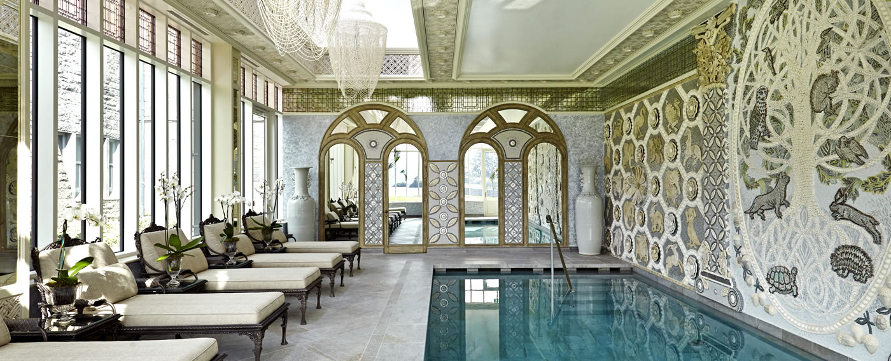
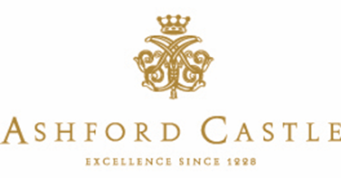
PRESS RELEASE
JANUARY 2017

ASHFORD CASTLE WINS “IRELAND’S BEST HOTEL SPA” AT THE 2017 WORLD SPA AWARDS™
Hotel Wins Prestigious Award for Second Year Running
The magnificent Ashford Castle has further cemented its outstanding reputation by adding yet another top international award to its collection. For the second year running the luxury 5 star spa has won ‘Ireland’s Best Hotel Spa 2017’ at the 3rd annual 2017 World Spa Awards™.
The World Spa Awards™ were developed to highlight fairness and transparency throughout the spa industry and act as a bench mark of excellence in order to foster a new era of growth in global spa tourism.
The glamorous 2017 gala ceremony took place at Phu Quoc's newest and only luxury five-star international resort – JW Marriott Phu Quoc Emerald Bay, the proud flagship of JW Marriott Hotels and Resorts in Vietnam set on the pristine beach of Bai Khem.
The consecutive win of this award is much appreciated following the property’s massive restoration project completed in April 2015. The Spa at Ashford Castle was the final luxury instalment in the historic property’s extensive restoration. The striking French-style conservatory is adjoined to the 800 year old castle and houses an indoor resistance pool offering views across the serene Lough Corrib.
State of the art facilities at the Spa include an invigorating Hammam, steam room, manicure and pedicure area, a tranquil relaxation suite and five treatment rooms, including a couple’s room, where guests can indulge in a vast range of pampering treatments. The Spa offers products from organic Irish brand Voya, internationally renowned Elemis and Red Carnation Hotel’s very own B|Africa product range, previously exclusive to the collection’s South Africa properties.

Ashford Castle is proudly part of Red Carnation Hotels, a collection of 17 stunning properties all landmarks of history and tradition, with an unrivalled reputation for outstanding five-star hospitality.
Ashford Castle is uniquely nestled on 350 acres of rolling West of Ireland countryside, overlooking the shores of Ireland’s second largest lake, Lough Corrib. The estate includes pristine gardens, originally created by Lady Ardilaun of the Guinness family and recently restored to their former glory during the hotel’s extensive restoration project; a 9 hole golf course; Ireland’s first School of Falconry; an equestrian centre; Ireland’s only Orvis-endorsed fishing school and newly resurfaced tennis courts, all to be enjoyed by guests of Ashford Castle and The Lodge at Ashford Castle.
For more information about Ashford Castle and to book your stay at the World’s Number One Hotel (as named by Virtuoso), please visit: www.ashfordcastle.com.
-Ends-
For further information and imagery, please contact: Denise Sheridan or Laura Dwyer, Kennedy PR + Brand
dsheridan@kennedyprandbrand.ie ldwyer@kennedyprandbrand.ie
Tel: 01 476 2000

ABOUT ASHFORD CASTLE:
Ashford Castle is set on 350 acres in County Mayo, on the shores of Lough Corrib and the River Cong, with a spectacular backdrop of woodlands, lake, river, and mountains. It features 85 guestrooms and is renowned for a range of country sports including an equestrian centre, Ireland's only Orvis-endorsed fishing school, an exclusive nine-hole golf course, newly surfaced tennis courts and Ireland's first school of falconry. Several dining rooms, bar, cinema, billiard room, cigar terrace, wine cellar, spa and gracious afternoon tea service are among the amenities. It is a member of Leading Hotels of the World.
For more information please visit www.ashfordcastle.com.

ABOUT THE RED CARNATION HOTEL COLLECTION:
The Red Carnation Hotel Collection is a collection of family-run, award-winning boutique hotels in the UK, Ireland, South Africa, Switzerland and the USA. From Ireland's recently restored Ashford Castle to South Africa's iconic Oyster Box, each hotel is a landmark of history and tradition that offers a unique character and unsurpassed service. Boasting a peerless reputation for exquisite fine dining, leading spas and sumptuous surroundings, Red Carnation Hotels are proud to deliver warm, thoughtful and highly personalized service to every guest, every time.
For more information about these award-winning hotels and the rest of the Red Carnation Collection, please go to www.redcarnation.com.
ABOUT WORLD SPA AWARDS
World Spa Awards™ serves to celebrate and reward spa industry excellence through an annual awards programme. World Spa Awards™ is the sister event of World Travel Awards™, which is celebrating its 23rd anniversary. World Spa Awards™ is a dynamic awards programme, launched in 2015, and is designed to drive up standards within spa tourism by rewarding the organisations that are the leaders in the field. Launched by the World Travel Awards, itself inaugurated in 1994, as a sister programme to the World Ski Awards and World Golf Awards, World Spa Awards™ is focused on the rapidly evolving spa and wellness sector.
For more information, visit www.worldspaawards.com

