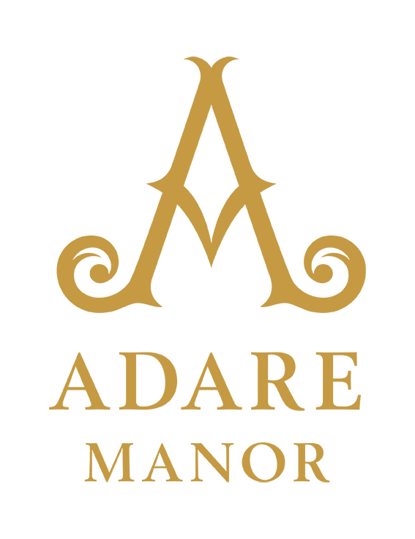

Adare Manor Reopens As A Top Resort in Europe Following Groundbreaking Transformation

Famed Castle & Golf Resort Begins New Chapter, Restoring Cherished Heritage of Hospitality

Limerick, Ireland (November 2, 2017) – Ireland’s most anticipated luxury hotel project, Adare Manor, opens today following a meticulous 21 month restoration, renovation and expansion to return the storied property to its 19th century splendour. Set on an 842-acre estate surrounded by medieval ruins, walled gardens and winding woodland paths, the preeminent European castle and golf resort welcomes a new 42-bedroom wing, expansive ballroom, La Mer spa, Tom Fazio designed championship golf course, and an exceptional gastronomy program to deliver an unforgettable guest experience.

“This marks a new beginning for Adare Manor’s esteemed legacy,” said Colm Hannon, CEO of Adare Manor. “A labour of love from the very start, Adare Manor was created by its original owners to delight, astonish, and impress – and we continue to hold ourselves accountable to that vision today, which is vividly alive in this new guest experience, and even further reflected by our world-class team, whose personalised service is what makes Adare Manor feel like home.”

Merging 19th and 21st Century Designs
Spearheaded by acclaimed architects ReardonSmith, the transformation preserved the building’s architectural heritage as a Neo-Gothic masterpiece, while incorporating contemporary luxuries and technological conveniences to meet the needs of today’s luxury traveller. The restoration involved internal finishes, furniture and woodwork, and repairing external stonework and windows. Most notably, the expansion added a new 42-bedroom wing and expansive ballroom, both of which are clad in limestone to honour the detail of the original Manor House.

A tribute to the sense of exuberance, wit and style of the original creators, Adare Manor is reminiscent of a chateau, sharing many features of the 19th century Gothic Revival in Britain and Ireland, and drawing inspiration from a romantic view of the chivalric past.

Today, the building still displays a wealth of gargoyles, heraldry and decorative stone and woodcarvings and maintains its identity as an example of a rare ‘Calendar House,’ adorned with 365 leaded windows, 52 ornate chimneys, 7 stone pillars and 4 towers to mark the annual tally of days, weeks and seasons.

Manor House Accommodations
Steeped in history and hidden secrets, each of Adare Manor’s 104 bedrooms is individually designed with its own personal touches, paying tribute to the creative force behind the original Adare Manor.

From Classic Rooms to Signature Suites, every room is individually designed and beautifully furnished, full of personal touches and carefully considered details. Guest rooms offer the perfect retreat, a place of ease and repose for guests to reflect on the joys of the day and anticipate the pleasures of tomorrow. With inviting beds, gorgeous historically inspired original art and furnishings, marble en-suite bathrooms, and beautiful views from every window, each guest room is carefully crafted for indulgence and relaxation.

Reimagined Grand Public Spaces
The Great Hall Reception is a fitting first taste of the breath-taking grandeur that visitors can expect upon entering the new Adare Manor, complete with soaring ceilings, vaulted arches and enormous windows. Functioning as a lobby for guest relations and check-in, a black marble fireplace acts as the centrepiece of the room, carved with intricate heraldic designs and crowned with an Old Master painting. Inviting armchairs and ottomans clustered around the hearth, and velvet, mohair and silk soft furnishings, add a cosy touch to the backdrop of marble and limestone, while bespoke hand-knotted silk and wool Tibetan rugs, so fine that only three inches can be woven in a day, sit boldly on the original parquet floor. Today, a new façade has been created to replicate where once an astounding pipe organ stood, and now conceals a discreet lift, which provides easy access from The Great Hall Reception to the upper levels of the manor.

The perfect marriage of grand scale and exquisite detail, The Gallery is a masterpiece within a masterpiece. The monumental scale of the room is purposeful, its design inspired by the great cathedrals and long castle galleries of Europe, and by the legendary Hall of Mirrors in Versailles. From the soaring arch of the ceilings to the magnificent stained glass and ancient woodcarvings, to the delicate china of the teacups, The Gallery is a magical setting for an indulgent and unforgettable dining experience – Afternoon Tea. An experience to savour, Afternoon Tea in The Gallery features a jewel-box menu of sweet treats, dainty cut sandwiches, perfectly crafted miniature pastries and warm scones with clotted cream and daily-made lemon curd, paired with an extensive selection of first-flush and specially blended teas from around the world, including Adare Manor’s new signature blend, 1832.

Overlooking the lush formal gardens, The Drawing Room exudes warmth and style, making it an ideal spot to meet for morning coffee or to enjoy light meals and refreshments throughout the day. In the evening, guests can enjoy traditional and innovative cocktails or take an aperitif as a prelude to dining in the Cocktail Bar.

Distinctive Gastronomy
Setting the standard for culinary excellence in exceptional surroundings, The Oak Room features an intimate, lovingly restored oak-panelled dining room aglow in candlelight overlooking the River Maigue – the perfect accompaniment for an unforgettable dining experience. Specialising in the very best seafood from sustainable sources and prime Irish meats and game, guests will enjoy exquisite cuisine along with an extensive wine offering and pairing menu curated by the restaurants’ Sommeliers.

Located beneath The Great Hall Reception lies The Tack Room, a sophisticated retreat for lovers of fine spirits and companionable conversation. The unique architecture belies its original, more humble purpose. Originally serving as the servant’s hall, a common room for house staff to gather to eat meals and socialise after hours. That history of relaxation and ease still remains in the room, now enhanced by the lush opulence of its rich leather, marble, and bronze furnishings and the gentle glow of low lighting from traditional fringed lamps and grand limestone fireplace. The original limestone floor is laid with three bespoke rugs, woven by a local Irish rug company and feature an abstract design inspired by the stained glass windows within the Manor House. The Tack Room boasts an extensive selection of bespoke cocktails inspired by the history and heraldry of the Manor, an impressive small-batch craft beer list, and a coveted collection of rare Irish whiskeys.

Special Events & Weddings
From a grand marquee event in the garden to a high-level board meeting, or intimate dinner party for six, Adare Manor offers a range of flexible indoor and outdoors spaces for parties of all sizes.

With a breath-taking backdrop and a fairy-tale setting, the Grand Ballroom is Ireland’s most impressive banqueting space for weddings. Catering to groups of up to 350 guests, the 445 square metres (4,800 square feet) ballroom features a grand sweeping staircase with beautiful natural light flooding through the floor-to-ceiling windows. Massive crystal chandeliers command the room, further enhancing the impression of grandeur and luxury. In addition, the ballroom boasts its own private entrance; separate cocktail reception area and outdoor terrace with breath-taking views overlooking the River Maigue.

A flexible and accommodating space for conferences, meetings, and gala dinners, the Grand Ballroom can be divided into three separate suites by fully soundproof folding doors with built-in AV and screens. A 30-seat Executive Boardroom and 28-seat Cinema complement the event capabilities and provide flexible meeting options for groups.

Spa & Wellness
Sitting within the heart of the Manor is one of only 11 spas in the world, and the only in Ireland and the UK, featuring legendary skin care brand, La Mer. A secluded sanctuary meant to provide an unparalleled experience for relaxation and renewal, The Spa at Adare Manor offers a bespoke treatment menu inspired by the sea to rejuvenate the mind, body and skin. Along with a selection of treatments, guests will discover La Mer’s most luxurious treatment, The Miracle Broth Facial. The indulgent facial incorporates Spa Broth™, an exclusively pure form of La Mer’s Miracle Broth™, to help re-energize, nurture and deeply hydrate, transforming the skin to reveal a youthful appearance.

Within this peaceful haven lies five treatment rooms, a nail salon, fully equipped fitness centre and plunge pool, open daily. Measuring 8 metres long, 5 metres wide and 1.2 metres deep, the plunge pool is surrounded by a spacious relaxation area with comfortable loungers, sauna and shower. Natural light streams through the vaulted skylight and the floor-to-ceiling windows, with beautiful views over the River Maigue and golf course. The soothing sound of water pouring over the weir just outside the windows creates the perfect ambiance for a relaxing swim.

Golf Reawakening
Adare Manor’s crowning feature, the 18-hole, par 72 golf course, has been reimagined by legendary golf course architect Tom Fazio, and will debut in spring 2018.

Promised to be one of the best golf courses in all of Europe, the championship course is set amid magnificent mature trees and aquatic features including a 14-acre lake and the River Maigue, and has been completely restructured to include a new arrival experience, driving range, caddy program and clubhouse. The new course will match the timeless grandeur of the Manor with a classic and well-manicured look, while enjoying new modern conveniences for an unparalleled golfing experience.

Estate Activities
The 840 acres of Adare Manor’s beautiful estate include walled gardens, walking trails and pristine parklands, where over 1,000 additional trees have been planted. Enhanced through loving restoration and landscaping, they create a magical backdrop for a wide range of exciting on-site activities both indoors and out, including falconry, archery, Irish gundog experience, cycling, fishing on the River Maigue, woodland walks and historical tours, movie screenings, and more.

A New Chapter in History
Adare Manor’s re-opening is the newest chapter in its legendary history. Commissioned by the 2nd Earl of Dunraven in the 1830’s as a personal project, meant to transform his own home into a spectacular masterpiece modelled after the great houses and cathedrals of Europe, Adare Manor would take nearly three decades to complete. It remained in the Dunraven family until the early 1980’s when it was sold and transformed into a five-star hotel. Over the next 25 years, it would go through multiple restorations and expansions, but always retains its original character of a beloved family home.

A member of Leading Hotels of the World and a Virtuoso Hotels Preview property, Adare Manor is now open and accepting reservations. For regular updates and additional information, please visit www.adaremanor.com.

###

Adare Manor
This castle hotel is situated in the heart of Adare Village in County Limerick. Steeped in history and surrounded by medieval ruins, Adare Manor is in the midst of a groundbreaking transformation set to debut November 2017. The largest restoration project of its kind in Ireland, the renovation and expansion honours the building's architectural heritage as a Neo-Gothic masterpiece while incorporating the latest in contemporary luxury. Most notably, the expansion included a new 42-bedroom wing, increasing accommodations to a total of 104 guest rooms, a ballroom which can host up to 350 guests, as well as a redesigned golf course by award-winning designer Tom Fazio. The 842 acres of Adare Manor’s beautiful parkland, walled gardens and walking trails were also enhanced and offer an extensive range of pursuits, including falconry, archery, clay pigeon shooting, fishing, state of the art spa and cinema. www.adaremanor.com

Media Contact:
J Public Relations
AdareManor@jpublicrelations.com

